Section 1: proportion of women by age group who are childless using scales and colouring relevant to each age group; ie. To show different regional variations in intensity of childlessness within Switzerland; also shows where early childbearing is common (ie. Rural areas) v. late childbearing

Data from Swiss census 2000
Part of childless woman in percent: 20 to 24 years old, 2000
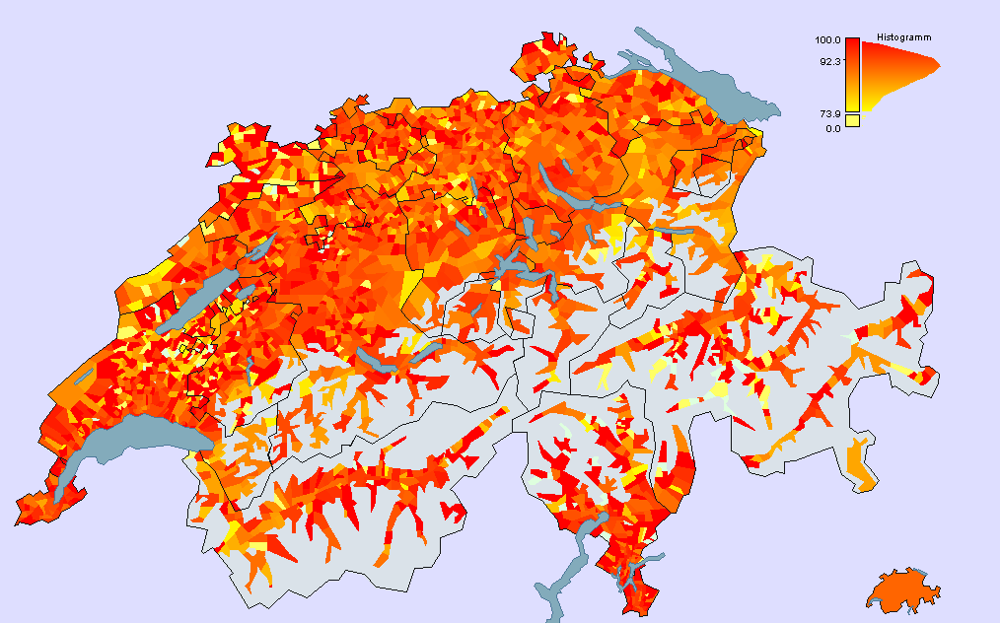
Part of childless woman in percent: 25 to 29 years old, 2000
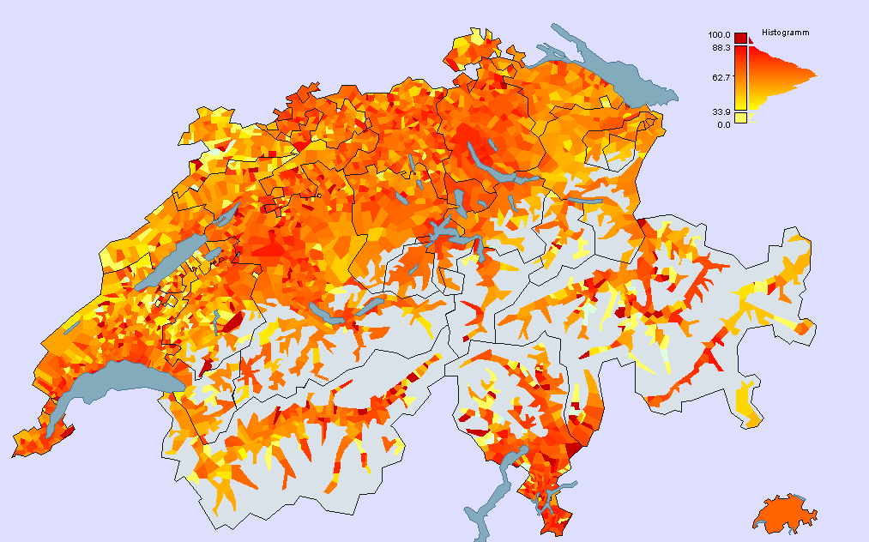
Part of childless woman in percent: 30 to 34 years old, 2000
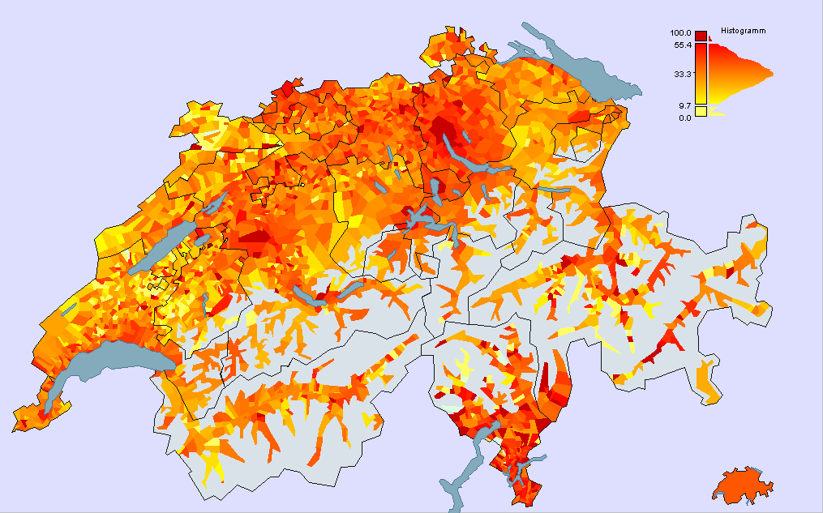
Part of childless woman in percent: 35 – 39 years old, 2000
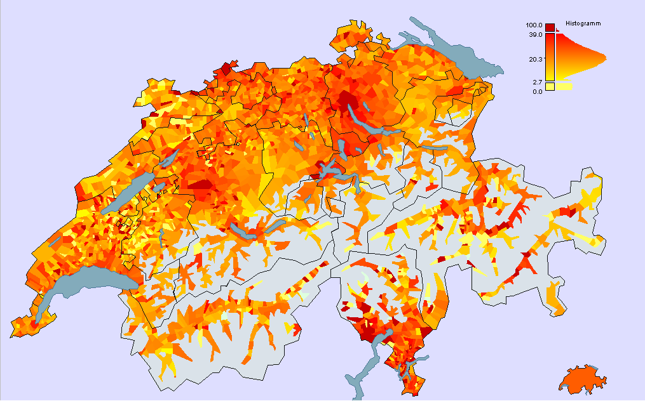
Part of childless woman in percent: 40 – 44 years old, 2000
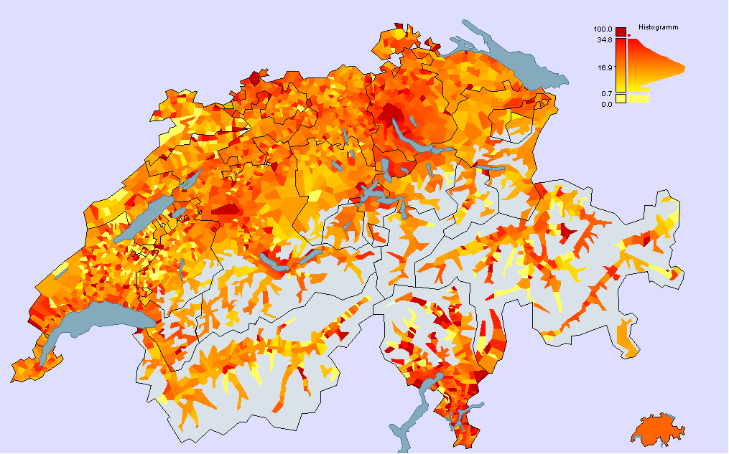
Part of childless woman in percent: 45 – 49 years old, 2000
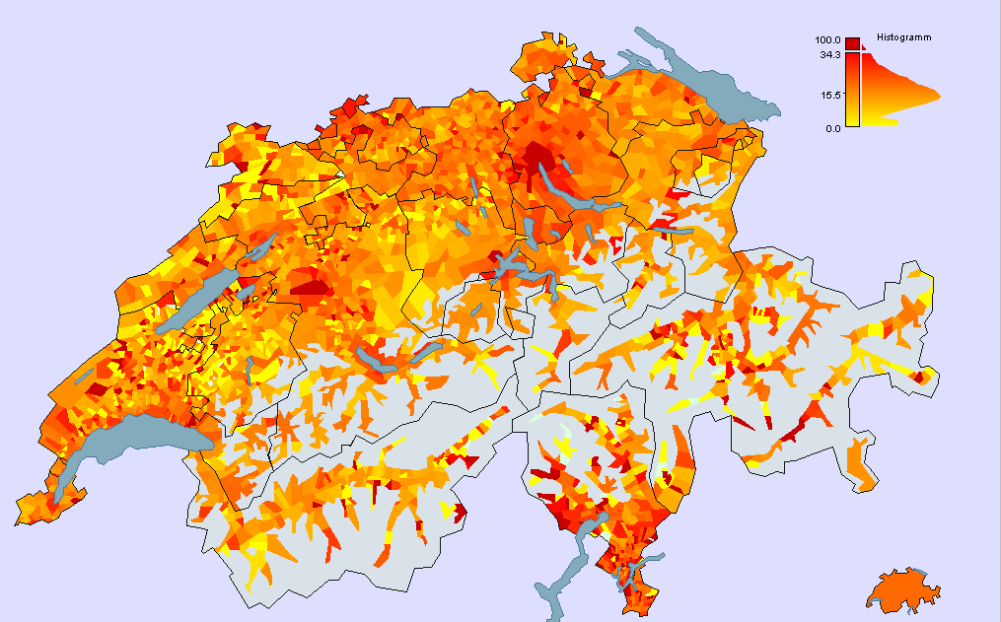
Section 2: proportion of women by age group who are childless using the same scales and colouring relevant for all age groups; ie. To show how childlessness declines as women get older, and the ultimate distribution of childlessness
Part of childless woman in percent: 20 to 24 years old, 2000
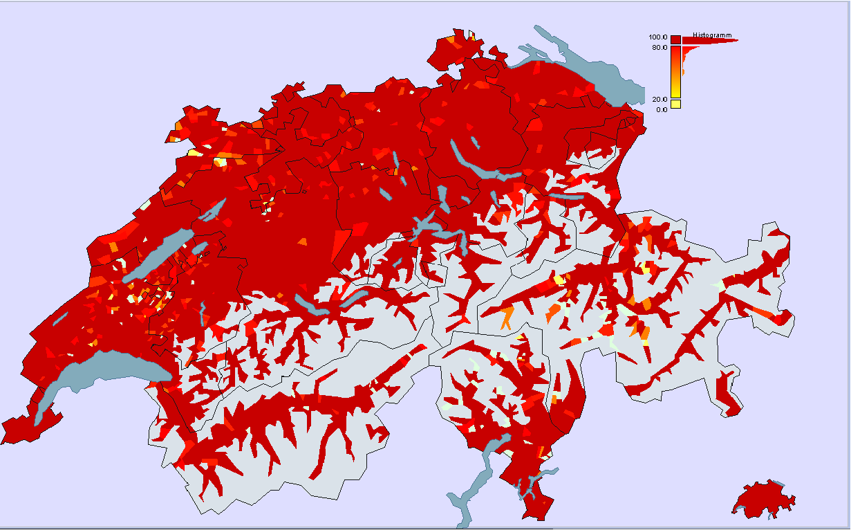
Part of childless woman in percent: 25 to 29 years old, 2000
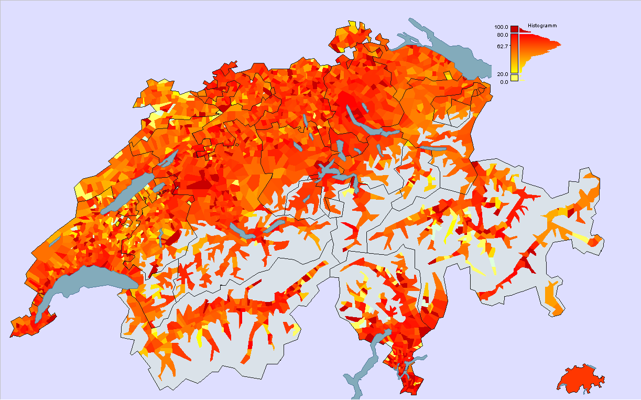
Part of childless woman in percent: 30 to 34 years old, 2000
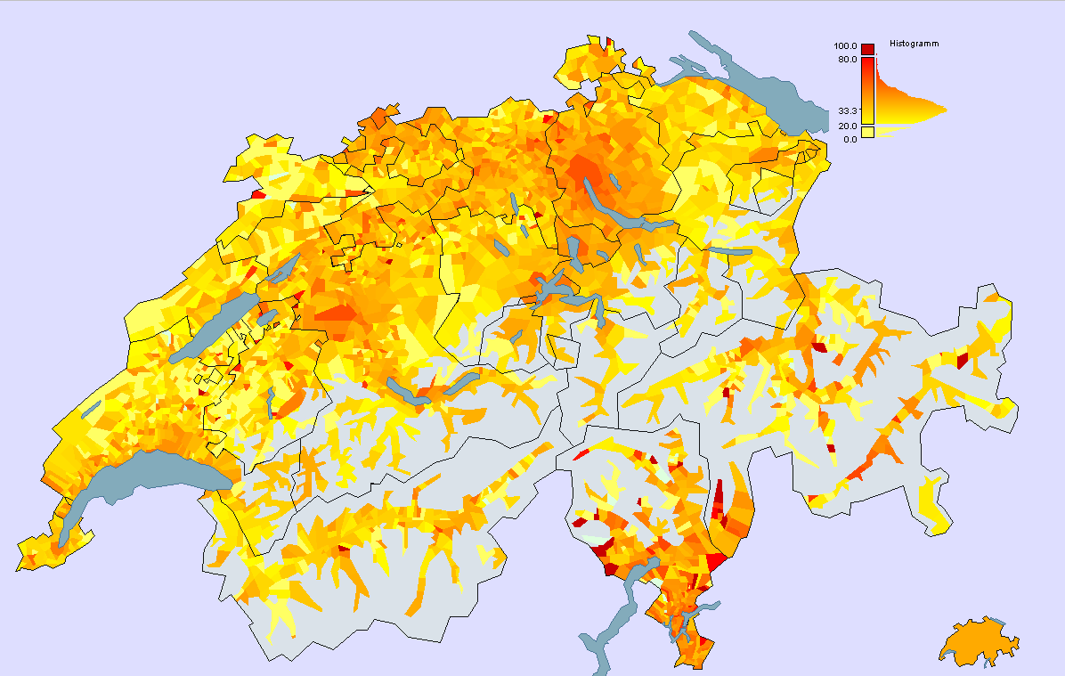
Part of childless woman in percent: 35 – 39 years old, 2000
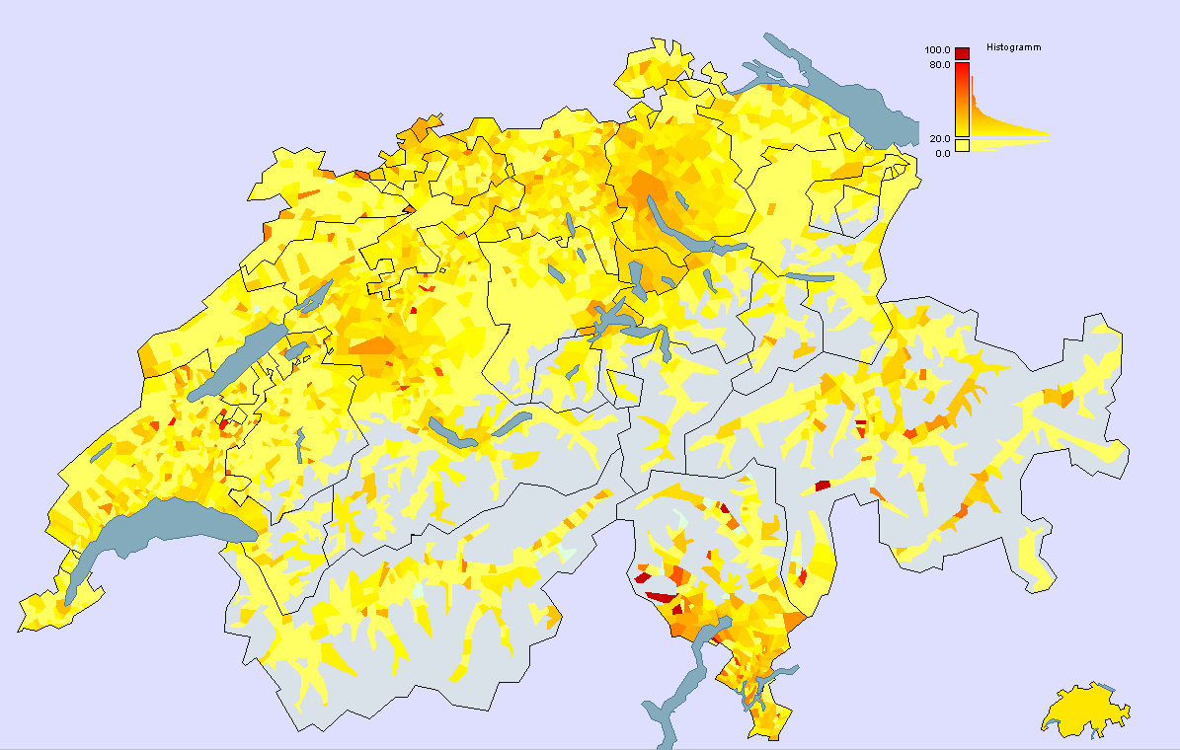
Part of childless woman in percent: 40 – 44 years old, 2000
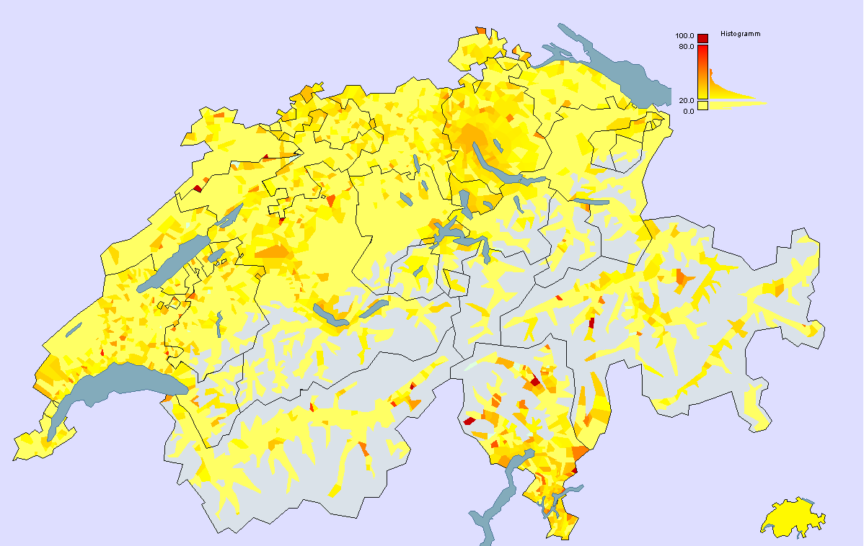
Part of childless woman in percent: 45 – 49 years old, 2000
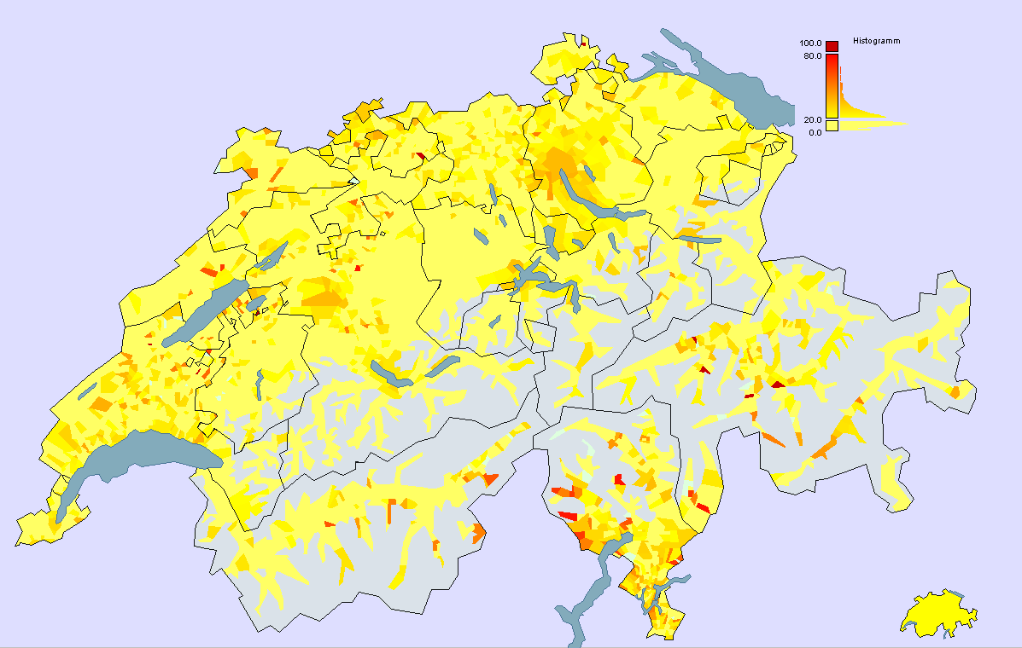
Conclusion:
Those regions which start childbearing later also end up with higher levels of childlessness: Ticino and the urban areas, especially around Zurich.

There is somewhat less childlessness in the French-speaking part of the country compared to the German-speaking part, but more in the Italian speaking part.

I had wondered whether early childbearing was common in the urban areas, but this is not the case. The highest incidence of early childbearing is in some rural pockets (see 1st map).

The rural/urban differentials increase over time (ie. With higher age groups considered). Could this be that new immigrants move to the cities, but these women tend to be childless? Or could it be that childless women move from rural areas to the cities as they get older in their potential reproductive life (because they are free to be more mobile). Or could it be that women tend to move (back to) to rural areas away from the cities once they have children?

