What makes people happy?
What makes people sad?
And where do you draw the line?
A preliminary investigation from Switzerland.

Marion Burkimsher
LaboDémo, University of Geneva

Introduction

Are people happy living in a chocolate box?

Switzerland’s natural beauty is sometimes described as chocolate box scenery. But are people happy living in such surroundings?

This study aims to investigate a number of factors that have the potential of affecting people’s happiness – and also whether these same factors affect the other end of the emotional spectrum – sadness. Are happiness and sadness opposite sides of the same coin? Or are the factors which cause people to be happy or sad quite different?

This short study examines just four factors which could have a bearing on life satisfaction: gender, age, civil status and place of residence – urban, suburban, rural or tourist area.

Literature review

The study of happiness – or “subjective well-being” or SWB as it is sometimes known – is a growing field of research. The performance of countries is now monitored in the World Database of Happiness (Veenhoven, ongoing). Countries can now compete for rankings on the Gross National Happiness index, as well as Gross National Product (Wikipedia, 2006). Serious academic research is reported in the Journal of Happiness Studies, which was launched in the year 2000. There is a university chair in 'Social conditions for human happiness' at the Erasmus University in Rotterdam. In March 2006 there will be a Symposium on the Economics of Happiness at the University of Southern California. The study of happiness lies within the scope of ‘Quality of Life’ research, and is generally in the domain of sociology or psychology, but can have links to economics, health and politics. In a recent edition of ‘The Economist’ (2006) there is a review of a new book on happiness, ‘Happiness: A history’, by Darrin McMahon, which plots the evolution of man’s ideas about happiness and its pursuit.

A useful summary paper is that of Diener (2000), which investigates some of the factors which influence happiness, as well as discussing the difficulties of measuring happiness. He notes that happiness and sadness had already been found in 1965 to correlate with quite different variables. Significant differences in average levels of happiness are seen over time and from one country to another. This is where politicians start to become interested in happiness measures – as they may consider that providing for the well-being and happiness of their citizens should be one of their goals. Even more likely, they know that if their populace is aware that they have become less happy, then they are likely to vote their leaders out of office – or perhaps more serious social unrest will erupt.

However, happiness in individuals is a very fleeting emotion – most people tend to a steady state, although the actual level may be different from one individual to another depending on their genetic make-up, state of health, etc. Crises or happiness ‘highs’ have only a short-term impact, although marriage has a longer-term positive effect, and widowhood an even longer term negative effect. Although several factors have been found to have some correlation with happiness (income, number of friends, religious faith, intelligence, education, etc), they were found to account for only 15% of the variance in happiness (Campbell, Converse and Rodgers,1976). Physical health, which could be expected to correlate with happiness, has been found to have little effect, although multiple disabilities lower a person’s happiness level.

Life satisfaction varies markedly between countries, although there is not a close relationship between a country’s wealth and the happiness of its citizens. The ex-communist states of eastern Europe rate particularly poorly, while China and India fare well in comparison to their income. The role of individualism, community support, inequalities and other society-level variables have been investigated (Veenhoven, 1993). With respect to this study, it is notable that Switzerland has the highest score in Diener’s synthesis, with a measure of 8.36 out of 10 for ‘life satisfaction’.

It should be noted that satisfaction has important correlates with health – happier people are healthier and live longer - are less likely to get divorced, they perform better at work and are more involved in the community. It is obvious, though, that the causes and effects of these correlations are bi-directional and there are positive and negative feedback loops.

The Swiss Household Panel Survey

A longitudinal survey entitled “Vivre en Suisse” (Living in Switzerland) was initiated in 1999 with 5074 participating households. These households were followed for five years. In 2002, there were completed questionnaires from 3690 households. Within those households, a total of 9542 individuals were interviewed. The database, therefore, consists of two parts; that relating to the household and that relating to individuals. Some of the answers from the household survey were added to the individual responses database. For the purposes of our analysis, 60% of the complete data set was made available (3079 households, 5677 individual respondents).

Questions relating to satisfaction

The results from three questions in the survey were examined in detail:

- ‘Satisfaction du niveau de vie’ (Satisfaction with standard of living). This question was given to main respondent of the household, and this same value was then assigned to every member of the household. It was question 61 out of a maximum of 209 questions and followed a number of questions concerning housing. Out of a maximum of 3079 respondents, 2989 gave valid responses to this question. In transferring this data over to the personal responses database, this gave 5513 valid responses out of 5677.
- ‘Satisfaction de la vie en général’ (Satisfaction with life in general). This was asked of individual respondents. It was question 23 in the personal questionnaire (though for principal household respondents, the personal questionnaire presumably followed the general household questionnaire). The question was after some general questions of education and nationality. The mean was 8.03: this is in good agreement with the country average noted by Diener (2000) which was 8.36 for Switzerland. His question was “How satisfied are you with your life as a whole these days?”.
- ‘Satisfaction de soi-même’ (Satisfaction with yourself / personal contentment). Again, this was a personal question and 3376 out of 5677 gave valid responses. It was question 392 on the questionnaire after many questions on various aspects of life (work, education, health, education) and opinions about those spheres of life.

It is not surprising that these three measures are extremely similar. The following graphs show their frequency distributions:
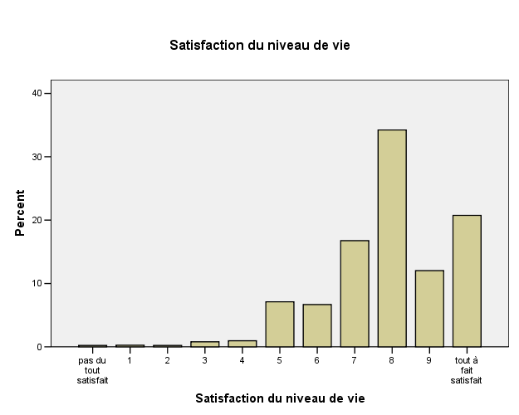

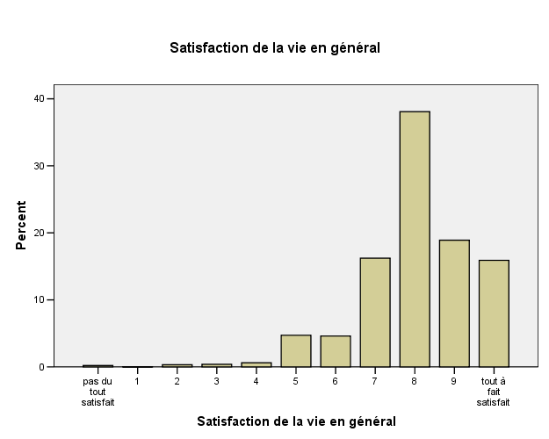

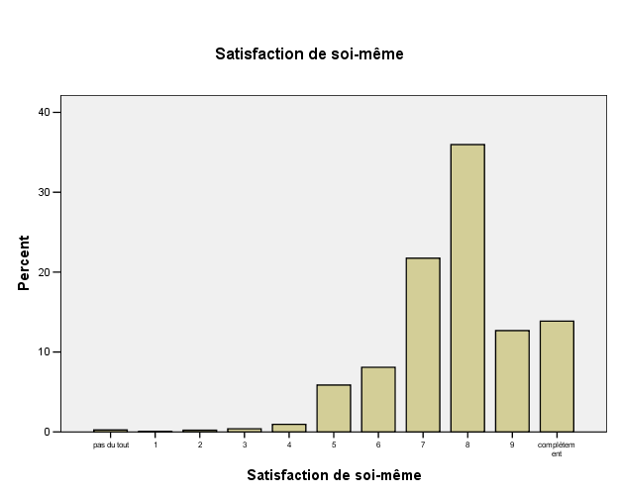

It would appear that although these measures are very similar, there is a slight fall in the level of satisfaction between the second question and the third. It is true that the questions are slightly different, with different nuances of meaning. However, I would suggest that a more likely explanation is that in going through the questionnaire, the respondent simply becomes less content. At question 392, a significant number of respondents are simply feeling bored/frustrated, and this is reflected in their answers. The transient nature of happiness is perhaps being seen here. It can also be noted that an additional 14 people gave invalid responses to the third question compared to the second question.

It is perhaps of interest to look at one other, rather more specific, measure of satisfaction that was examined in the questionnaire: Satisfaction with one’s state of health (‘Satisfaction de l’état de santé’). This was question 85 on the personal questionnaire. Out of a maximum of 5677 respondents, 3389 gave valid responses to this question (one fewer than for the second question). The spread was a little wider for this distribution.
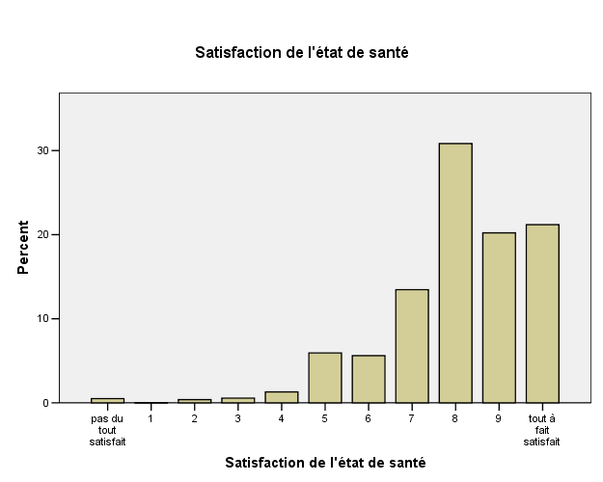

The following table summarises the results of the various measures of satisfaction relevant to this study:

The levels of correlation were calculated between all four measures of satisfaction (see table below): all were highly significant.

Associations between explanatory variables

It thought that it might be illuminating to examine whether there were any associations between the explanatory variables. It is clear that there would be a strong correlation of civil status with age, with the proportion of married people and subsequently the separated, divorced and widowed increasing with age, and the proportion of singles decreasing.

However, as type of commune was also of particular interest then the crosstabs of commune with age and civil status were calculated: these were found to be significant, as shown in the following table:

Looking at the raw data, we find that the separated, divorced and widowed have a greater propensity to live in the city than the countryside, while married people have a greater tendency towards suburbia. There are also significant differences in where different age group choose to live.

Combined measure of satisfaction

It was decided to compute a combined measure of satisfaction using the three primary measures of satisfaction detailed above. Any individual who gave an invalid response to any of the three relevant questions on satisfaction was not included in the analysis, ie. any responses with a value zero or less for any of the three questions.

The valid responses were then summed, to give a combined ‘satisfaction index’ of between zero and 30 (because each measure was out of 10). There were 3261 valid respondents. This is the frequency graph for the combined measure of satisfaction:
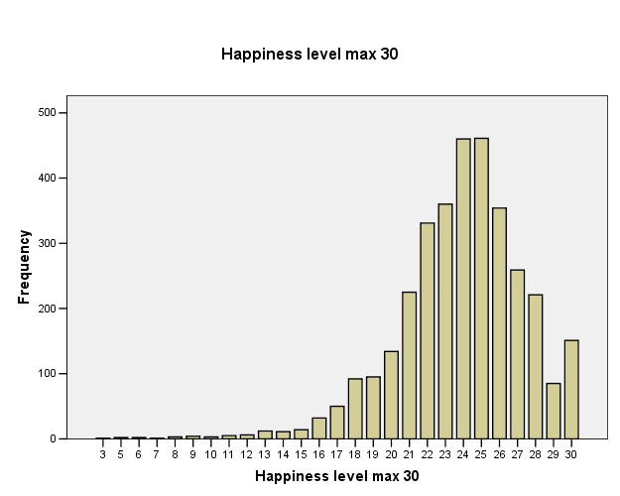

To proceed with a binomial categorical analysis, it was then necessary to split this measure of satisfaction into two categories. It was decided to compute three separate variables, dependent on different thresholds of the satisfaction index:
- A measure of ‘happiness’. An index of 27 (average score of 9 or over) and over was defined as ‘happy’. Out of all respondents, 671 (21%) could be classified as ‘happy’ and 2590 (79%) ‘less happy’.
- A measure of ‘satisfaction’. An index of 24 (average score of 8 or over) and over was defined as ‘satisfied’. Out of all respondents, 1914 (59%) could be classified as ‘reasonably satisfied’ and 1347 (41%) ‘less satisfied’.
- A measure of ‘sadness’. An index of under 21 (average score less than 7) was defined as ‘sad’. Out of all respondents, 458 (14%) could be classified as ‘sad’ and 2803 (86%) ‘not sad’.

This bar graph demonstrates the distributions (note these proportions are different in the multinomial analyses presented later):

Gender, age, civil status and commune type variables

Gender was recorded as male or female. Of 3261 respondents analysed, 1439 were male and 1822 were female.

Age (in years) during the year of the interview was recorded. To simplify the analysis, the respondents were classified into 10-year age bands. All respondents aged 15 and under were discounted and not included in the main analysis. Thus the age bands were 16-25 (inclusive); 26-35; 36-45; 46-55; 56 and over. This is a plot of the frequency distribution:
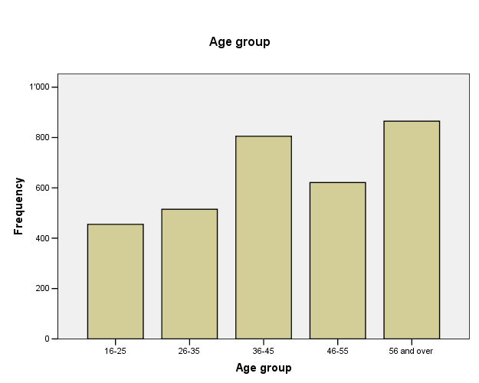

Two different variables of commune type were recorded in the questionnaire: one a very detailed classification of 22 different types (from ‘Communes semi-touristiques’ or ‘Communes en forte regression démographique’ to ‘Communes périurbaines de regions non metropolitaines’ or simply ‘Communes riches’). It is not known who made these classifications – the respondent, the interviewer or the agency in charge of the data collection.

A second, simpler, classification of commune type was also provided, with 9 categories. To simplify this analysis even further, I reduced the number of classifications to four, as follows:
- Urban communes were those classified as ‘centres’ and ‘industrielles & tertiares’.
- Suburban communes were those classified as ‘suburbaines’, ‘riches’ and ‘periurbaines’
- Rural communes were those classified as ‘rurales de navetteurs’, ‘agricoles mixtes’ and ‘périphériques’.
- Communes classified as ‘touristiques’. Although it is probable that they would generally also be rural, I was hesitant to classify them as such, and so they remain as a separate category ‘tourist place’.
The following graph shows the frequency distribution of respondents by type of commune:
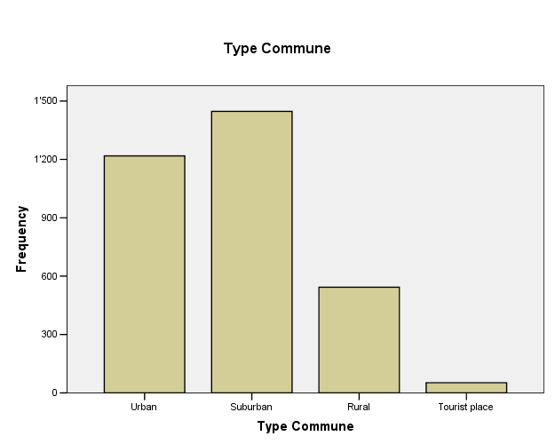

Bivariate tests – non-parametric correlation measures

The aim of these tests was to determine, for each of the three measures of well-being (happiness, satisfaction or sadness), their level of correlation with sex, age group, civil status and type of commune.

The following table summarises the Pearson’s chi-squared measures:

To examine these associations in more detail, the Cramer’s v measure was calculated for the nominal variables - civil status, sex and commune type. In the case of the variable ‘age group’, two tests of correlation for ordinal variables were carried out: Kendal’s tau-b and Somer’s d. However, although ‘age group’ is an ordinal measure, it was of interest whether the correlations with the different age groups behaved in a non-linear fashion, and therefore, in addition to the above mentioned tests, Cramer’s v test for nominal variables was also carried out. As an association with sex was found for happiness and sadness, it was important to know in which direction this was: therefore the ordinal tests were also performed for sex.

These tables show some very interesting results and relationships.

Perhaps the clearest conclusion is that the type of commune has no influence whatsoever on the level of happiness – or sadness. Clearly the effect of the external environment, whether a tourist area, rural, urban or suburban has an insignificant effect on a person’s level of well-being.

The second important conclusion is that the factors closely correlated with ‘happiness’ are markedly different from the factors influencing ‘sadness’. The determinants of happiness are seen to be firstly age group and secondly gender. For sadness, the primary determinant is civil status, closely followed by age group (also significant at the 1% level), with gender also having a significant influence (at the 4% level). The correlations for ‘satisfaction’ reflect an intermediate position between those for happiness and sadness, with civil status being the primary determinant and age group being the secondary influencing factor.

Looking at the ordinal analysis for ‘age group’ shows a very interesting pattern. The correlation measures (Kendall’s tau and Somer’s d) for ‘satisfaction’ show no significance – yet for ‘happiness’ and ‘sadness’ they are significant at the 1% level. The Somer’s d measure give a clue to the explanation of this, as it shows the direction of the relationship. For ‘happiness’, there is a positive relationship, ie. the higher age group a person is in, the more likely they are to be happy. For ‘not sadness’ there is a negative result for Somer’s d, which means that the higher age group a person is in, the less likely they are to be not sad, or in other words that older people are more likely to be sad. From the raw data we see that 11% of 16-25 year olds are ‘sad’ and this goes up to 16% of the over 55s. At the same time, 20% of the youngest age group classify themselves as happy, which goes up to 26% for the oldest age group. In other words, older people are more likely to be either happy or sad – and less likely to be in the middle ground.

The table also indicates that gender has a significant influence (at the 5% level) on happiness and sadness. But who is happier? Or sadder? The Somer’s d measure provides the answer. Women (coded 2, while men are coded 1) are more likely to fall in the ‘happy’ bracket, as opposed to men; but the negative value for Somer’s d for the ‘not sadness’ measure indicates that women are also more likely to be sad! This is similar to the somewhat anomalous result for older people discussed above. Women have a tendency to be both happier AND sadder! Or is it that men that men tend to moderate, or at least not admit to, their emotions – to keep on a more even keel in general? As could be expected, the measure of ‘satisfaction’ shows no level of correlation with age group or gender, as this is the mid-point measure between ‘happiness’ and ‘sadness’.

Binomial regression analyses

To investigate the relationship of happiness, satisfaction and sadness with the explanatory variables - sex, age group, civil status and type of residential area - a number of regression analyses were carried out.

Firstly a forward stepwise regression was carried out to investigate which variables, of the four being studied, had the most effect on the three dependent variables, happiness, satisfaction and sadness. The following table shows the variables which were extracted at each step in the analysis and the results of the significance tests.

Looking at happiness, we see that age group is the primary determinant for this, with gender being a minor influence (as the BIC between the model with sex added as an explanatory variable is only just over 2, then the additional influence of gender is small). Civil status and type of commune have no significant effect on the chance of a person having a high level of happiness.

For both satisfaction and sadness, the primary determinant is civil status, with age group also having a marked effect. The addition of ‘age group’ as an explanatory variable improves the model especially for sadness (increase in BIC of 29). Gender and type of commune have no significant effect on general satisfaction or likelihood of being sad.

In addition regression analyses were carried out including all the variables, in order to use each as controls for the others. The following table shows the odds ratios when all variables were included in the model.

This gives a useful overview of the effects of different variables. Even though not all the effects are statistically significant, the recurring patterns can be detected. For all measures, the type of commune had no relevance to level of satisfaction. Looking at civil status, married people tend to be more likely to be happy compared to singles, while those who are separated, widowed or divorced are less likely to be happy. However, married life is more a protection against being sad than creating happiness per se: for happiness, the correlation is insignificant, while that for ‘not sadness’ is. Controlling for age and sex, then for every 100 singles who are not sad, there are 146 marrieds, but only 71 people who have lost their partner.

As discussed with the statistical measures in the previous section, women have a tendency to be both happier than men and are also less likely to be ‘not sad’, in other words, to be more likely to be sad.

If we plot the odds for greater happiness, Exp(B), against age group for the three measure of satisfaction, then a curvilinear relationship becomes apparent for all three measures. There is a dip in happiness for the middle age groups compared to those who are younger or older.

Note that for all these graphs, the higher the bars the higher the proportion of happy/satisfied/not sad people.

Multinomial regression

Because of the complexity of the relationship between happiness and sadness and the various explanatory variables, it was decided that a multinomial regression analysis would be carried out to see if it would throw further light on the different factors affecting the level of well-being. For this, the satisfaction index (on a scale 0 to 30) was used to classify individuals into three groups, rather than two, as with the previous analyses. The three groups were ‘happy’ (score 27 and over); ‘reasonably satisfied’ (score 24, 25 or 26); and ‘sad’ (score of less than 24). (Note that the boundary for ‘sad’ is different for that used in the binomial tests, in which the threshold was set at 21, the boundary below which was one presumed to be ‘sad’. The boundary of 24 reflects the dichotomy between satisfied or not. It is likely that more significant results would have been obtained if the lower boundary again been used). The following table summarises the results:

A stepwise model was used and this selected the significant variables to be age group, civil status and sex, with type of commune not being included as it did not improve the model. The variables that were selected (automatically) at each step were as follows: age group at step 1, civil status at step 2 and sex at step 3.

The following table summarises the tests of statistical significance of the model:

Looking at graphs of the variation in the chances of happiness and sadness over the different age groups again confirms the previous hypothesis of a U-shaped curve: those of middle age are less likely to be happy and more likely to be sad than the young or old. Note in the second of these graphs the likelihood of sadness itself is plotted, and not its inverse. Therefore the two curves in the following graphs have an inverse relationship.

The multinomial regression again brings out clearly that although having lost a partner increases the likelihood of being sad, it does not make you happy. There is absolutely no difference in the likelihood of being happy in relation to civil status.

The multinomial regression also demonstrates the previously stated finding that women are more likely to be in the ‘happy’ or ‘sad’ categories.

Induction trees

These are another tool to explore the main factors influencing a certain variable – in our case happiness, general satisfaction and sadness. The following graphs were produced by SPSS, although the results are identical to those from the program AnswerTree, from which the analytical statistics were derived. The first tree is for ‘happiness’, ie. examining the factors for individuals who scored 27 or higher in the satisfaction index.

So who are the happy people according to this analysis? First the over-55 age group – males and females - is identified. Secondly, for men it is youth (ages 16-25) that makes them more likely to be happy. Thirdly, for women, being single or married is more likely to predispose happiness compared to being separated, divorced or widowed. The following graph indicates the ‘gain’ from adding the extra explanatory variables:

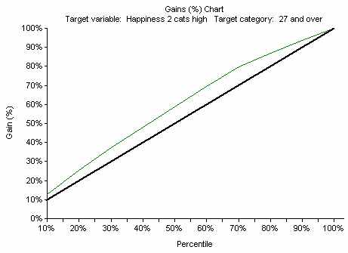

This shows that the gains are not very marked: however, they are statistically significant.

Secondly we will look at which groups of people are more likely to be satisfied (index of 24 and over), as opposed to less likely to be satisfied. This is the induction tree for ‘satisfaction’:
What do we deduce from this? Firstly, singles and married are more satisfied with life than the separated, widowed and divorced. Among this latter category, those older than 55 are more likely to retain a measure of happiness, and in particular men. In fact, a remarkable 72% of older men who have lost their partner are reasonably happy.

Here is a summary of the gains pertaining to this analysis of satisfaction, which shows that although the divisions at each level are statistically significant, the gains are, in fact very low:
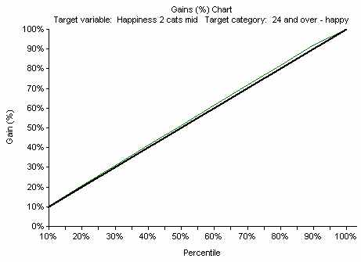
Finally we will look at the induction tree for sadness. Sadness is defined by a satisfaction index of less than 21.

Who are the groups of people who are most likely to fall into the ‘sad’ bracket? The clearest division is those who are separated, divorced or widowed. The under 35s are seen to be less likely to be sad than those who are older than this, and among the over 35s, singles are more likely to be sad than marrieds.

This graph indicates the gains from each step of the tree, which suggests that the first division, in particular (ie. the civil status split) is markedly important:
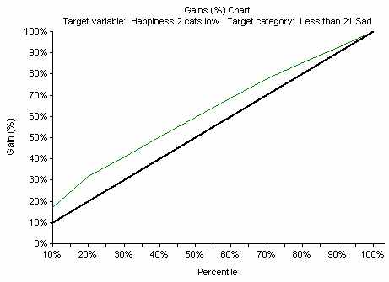

Induction tree with 3-way division of satisfaction

The final statistical exercise was to construct an induction tree with the 3-way measure of satisfaction, as used in the multinomial regression analysis. It should be noted that the choice of boundary between ‘reasonably satisfied’ and ‘sad’ was probably set rather too high (it would have been better at a satisfaction index level of 21, rather than 24).
This tree has yet another pattern compared to those presented before. Here, the main determinant of happiness level is age, with the over-55s again leading the field in highest happiness levels. There is a clear defining feature of what causes sadness in the under-36 age groups – losing a partner. In the middle age group (the 36-55 year-olds) then women are more likely to be happy, and less likely to be sad, than men.

Conclusions

This brief analysis has shown how the study of happiness or well-being is a very complex subject.

First, the choice of threshold for defining who is ‘happy’, ‘sad’, ‘more content’ or ‘less content’ is critical. It has been clearly shown that the factors that influence whether a person is happy are quite different from those that determine whether a person is sad. This demonstrates that caution needs to be exercised when interpreting other researchers’ results on apparent correlations of various factors with well-being.

Perhaps the clearest conclusion from this analysis is that place of residence plays no significant role in determining a person’s level of well-being. Whether a person lives in an area of outstanding scenic beauty or a city centre, this has no effect on their general happiness level: other factors flood this out.

However, age, gender and civil status do have important influences. These can be remarkably contradictory. Woman have more likelihood to fall into the very happy and markedly sad categories. The over 55s are also more likely to be happy or sad compared to younger ages. There is a dip in happiness level through middle age, which affects particularly men. Young men are happy – but also older men who have lost their partner at some stage through separation, divorce or widowhood are surprisingly happy.

Each of the above types of statistical analysis has thrown new light onto this investigation: bivariate tests, binomial and multinomial logistic regression, and induction trees.

Discussion

This study has confirmed many previously published results on the study of happiness. The fact that different things predispose happiness as opposed to sadness is quite crucial, as discussed by Diener (2000).

The strong effect of age on happiness levels is interesting, as it has previously been considered to be quite a minor influence, although the following diagram, from Myers and Diener (1995) hints at a similar effect as found in this study:

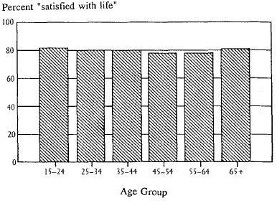
The U-shaped curve shown above, and found in this analysis of the Swiss Panel Survey suggests that it might be a widespread effect: that the young and the old are generally happier than the middle aged. The happiness of young people in Switzerland was discussed in a recent edition of a local Geneva newspaper, Le Matin Bleu (2006). To quote them: “Un tiers des célibataires suisses indiquent même franchement être ‘satisfaits’ ou même ‘très satisfaits’ de leur statut actuel. La frustration est un sentiment pratiquement inconnu chez les singles helvètes chez qui seuls 10% affirment en ressentir parfois. Ils sont six fois plus nombreux en Grande-Bretagne”. The article suggests that the higher income of the Swiss may help to keep them happy.

The finding that women tend to be both happier and sadder was also noted in the paper by Myers and Diener (1995). To quote them: “Women’s more intense sadness, given bad circumstances, must be considered in the light of their greater capacity for joy under good circumstances”.

The findings of civil status having a strong influence on happiness – and particularly sadness for those who have lost a partner – is not surprising, and is well documented (eg. Diener, 2000) – although the rather odd finding of happy older men who have lost their partner is rather surprising.

My initial hypothesis that home surroundings – whether city, suburbia or countryside – may have an influence on happiness levels was resoundingly rejected by this analysis of Swiss data. Personal factors have an overwhelming effect on happiness levels, and external environment has a very limited impact.

Further research possibilities

The Swiss Panel Survey has a huge number of variables that could be analysed further to see if they have any effect on well-being. It would be interesting to look at potential explanatory variables such as education levels, employment type, religious practice, age of children, number of people sharing a household, language, nationality, income, recent change of residence, and more.
It would be interesting to test the hypothesis that size of social circle influences happiness, and whether it is the number of different social circles that a person is involved with that is important, or their type - for instance whether voluntary work, sports clubs, religious participation, or meeting friends have different levels of influence. To investigate the causes of sadness then a number of hypotheses could be tested, eg. ill-health or sharing a household with a teenager or dependent old person.

Concerns with data

As happiness is a transient emotion, it would be helpful if questionnaires such as the Swiss Panel Survey included a variable describing the type of weather at the time of the interview. It would be interesting to see if this had any significant effect – and if it did, then it should be controlled for when making comparisons.

A major concern with all surveys of this kind is the response rate. Do the people who did not respond, either to the whole questionnaire or just the questions on happiness have the same distribution of ‘happiness’ as those who did respond? It is possible that busy people, who do not have time to devote to doing such a questionnaire, may be happier. Or it may be that those who do not want to respond have a more negative view on life (I would tend to that latter opinion, though I have no evidence for it).

Finally, do respondents really feel free to give honest answers to how happy they feel? If other household members are present, could this not ‘force’ people to say they feel happier than they really do? Or are they really happier when other people are around? There certainly seems to be a propensity for the Swiss to answer ‘8 out of 10’ for any question on satisfaction, whether satisfaction about their health, their accommodation (Wizard, 2006) or their life in general. Is there a cultural reason for this? Or are the Swiss really as happy as they appear to be from questionnaires?

References

Campbell, Converse and Rodgers,1976. The quality of American Life. New York: Russell Sage Foundation.

Diener, E. 2000. Subjective Well-Being. The science of happiness and a proposal for a national index. American Psychologist, Vol. 55, No. 1 34-43

The Economist (magazine). 2006. A strangely newfangled idea. Book review of ‘Happiness: a history’ by D. McMahon. Edition of 14-20 January 2006, p. 82.

Le Matin Bleu. 2006. Célibataires suisses: si ce n’est pas le bonheur, ça y ressemble. Edition of 20 January 2006, p. 3.

Myers, D. G., & Diener, E. (1995). Who is Happy?. Psychological Science, 6, (1), 12-19. Reprinted on website: http://www.uvm.edu/~dhowell/lies4thedition/Classfolder/Happiness/Myers.html

Veenhoven, R. 1993. Happiness in nations. Subjective appreciation of life in 56 nations 1946-1992. Erasmus University Rotterdam.

Veenhoven, R. States of Nations, World Database of Happiness
Website: http://worlddatabaseofhappiness.eur.nl

Wikipedia, 2006. Gross national happiness. Website downloaded on 3 Feb. 2006. http://en.wikipedia.org/wiki/Gross_national_happiness

Wizard, J. 2006. Etude satisfaction et logement. University of Geneva.

